Section 2
Num1 = DB (=11011011)
Num2 = AE (=10101110)
- Pick 6 and 7th bits of num1 10
- Replicate 2 times 1010
- Pick first three bits of num1 011
- Pick first 4 bits of num2 1110
- Concatenate d,c, and b -> [ 1110 011 1010 ]
- Divide concatenated number by constant 110010
- Verilog module (dataflow), RTL scheme, Testbench, Simulation
Result = 100101 = h25
Hint: In your verilog modüle, there should be:
2 inputs
1 output
1 parameter
5 wire variables
6 assignmets
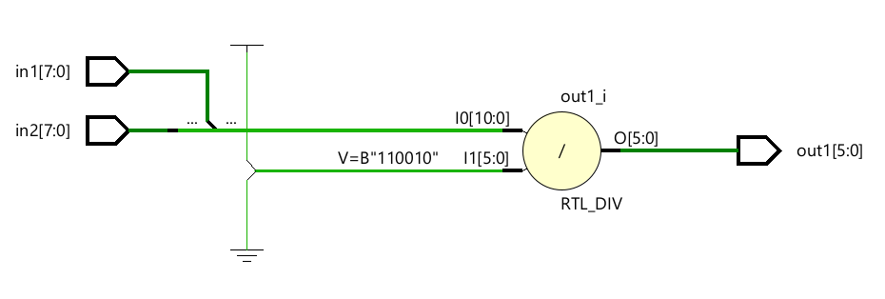
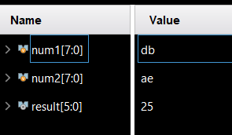

Section 3
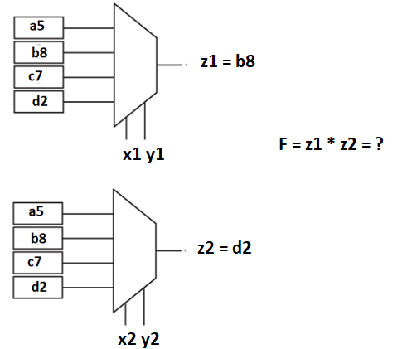F = 96f0

Section 1

Num1 = DB (=11011011)
Num2 = AE (=10101110)
- Pick 6 and 7th bits of num1 10
- Replicate 3 times 101010
- Pick first 4 bits of num2 1110
- Divide replic / pick2 101010/1110 = 11 (42/14=3)d
- Verilog module (dataflow), RTL scheme, Testbench, Simulation

module sys(in1,in2,out1);
input [7:0] in1,in2;
output [1:0] out1;
wire [5:0] wire1;
wire [3:0] wire2;
wire [1:0] wire3;

assign wire3 = in1[6:5];
assign wire1 = {wire3,wire3,wire3};
assign wire2 in2[3:0];
assign out1 = wire1 / wire2;

endmodule

module sys_tb;
reg [7:0] in1, in2;
wire [1:0] out;

sys UUT(.in1(in1), .in2(in2), .out1(out));

initial begin
in1 = 8’b11011011;
in2 = 8’b10101110;
end

endmodule

